School Visit Programme 2026
Kestrel Ridge, Harrow Bay and Millbrook
Tom Berger · 31 August 2026

Aims
- Give pupils a first-hand look at how renewable energy works
- Inspire interest in STEM careers – especially among girls
- Build trust with families in the communities around our sites
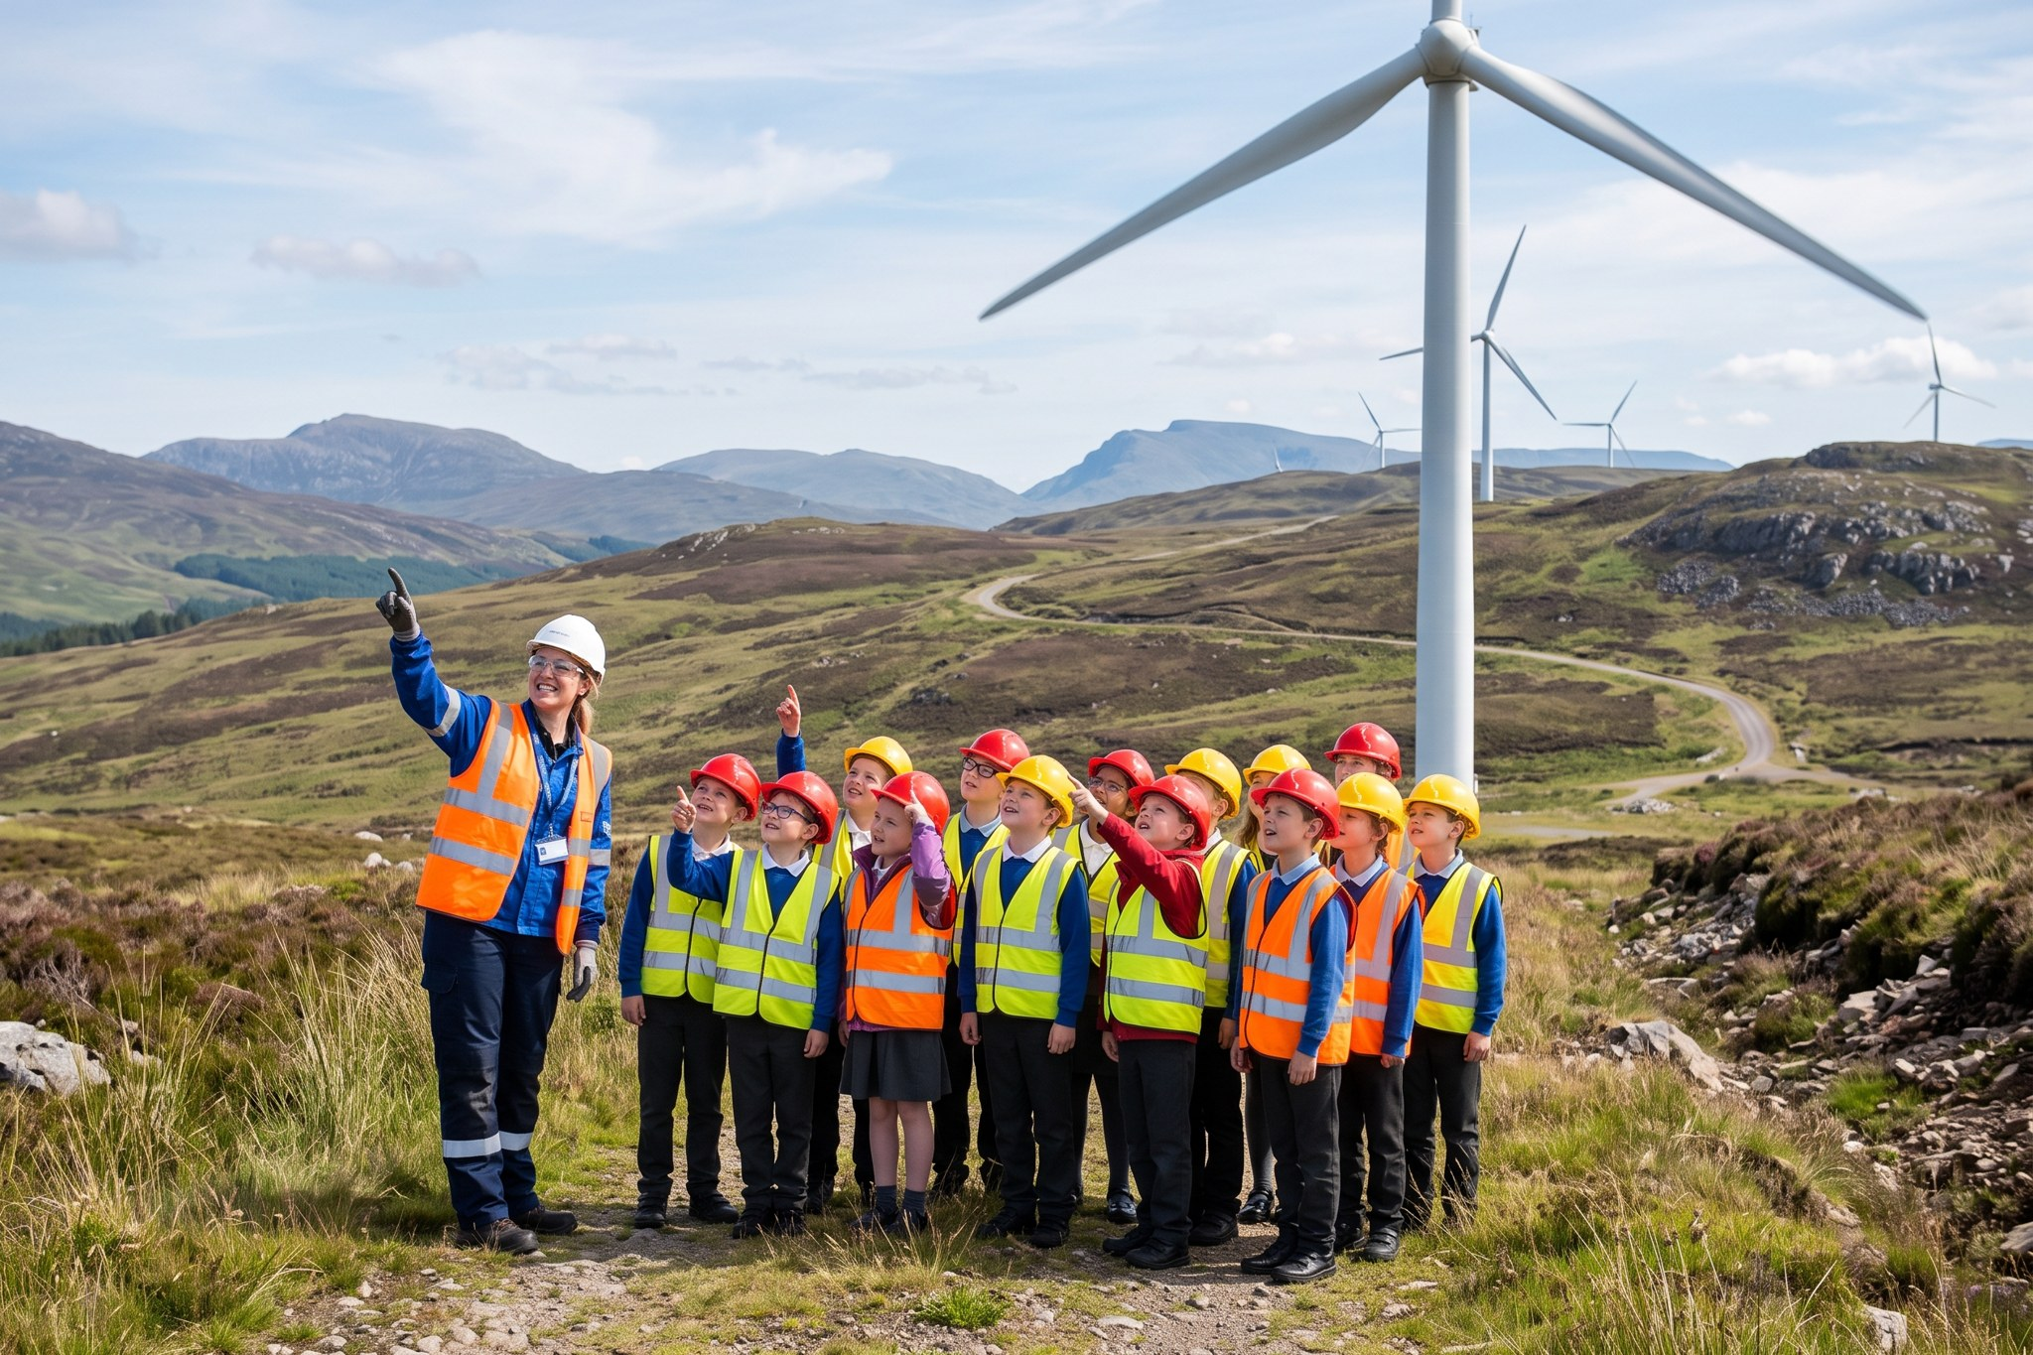
P6 pupils from Lowmoor Primary at turbine T-03, June 2026

Format
Element | Duration | Notes
Safety briefing and PPE | 15 min | Child-size hard hats and hi-vis vests from the site cabin
Walk to turbine T-03 viewing area | 30 min | Never closer than 150 m to an operating turbine
Talk by a technician (Highline Wind Services) | 20 min | What a day in the nacelle looks like
Classroom activity: build a mini turbine | 45 min | Activity sheet, kits re-used
Q&A and packed lunch | 30 min | In the visitor room

Safety
Every visit has a risk assessment approved by the site manager (Ben Okoye). Ratio one adult to eight pupils. Visits are cancelled if the wind speed forecast exceeds 15 m/s or there is a lightning warning.

Numbers
So far in 2026: 356 pupils from 8 schools. Target for the year: 600. Three visits are booked for the autumn term.

Millbrook
Because Millbrook is not built yet, Grace visits Millbrook CE Primary for a classroom session on solar energy and skylarks. A follow-up visit to the site is planned for after construction (2028/29).

